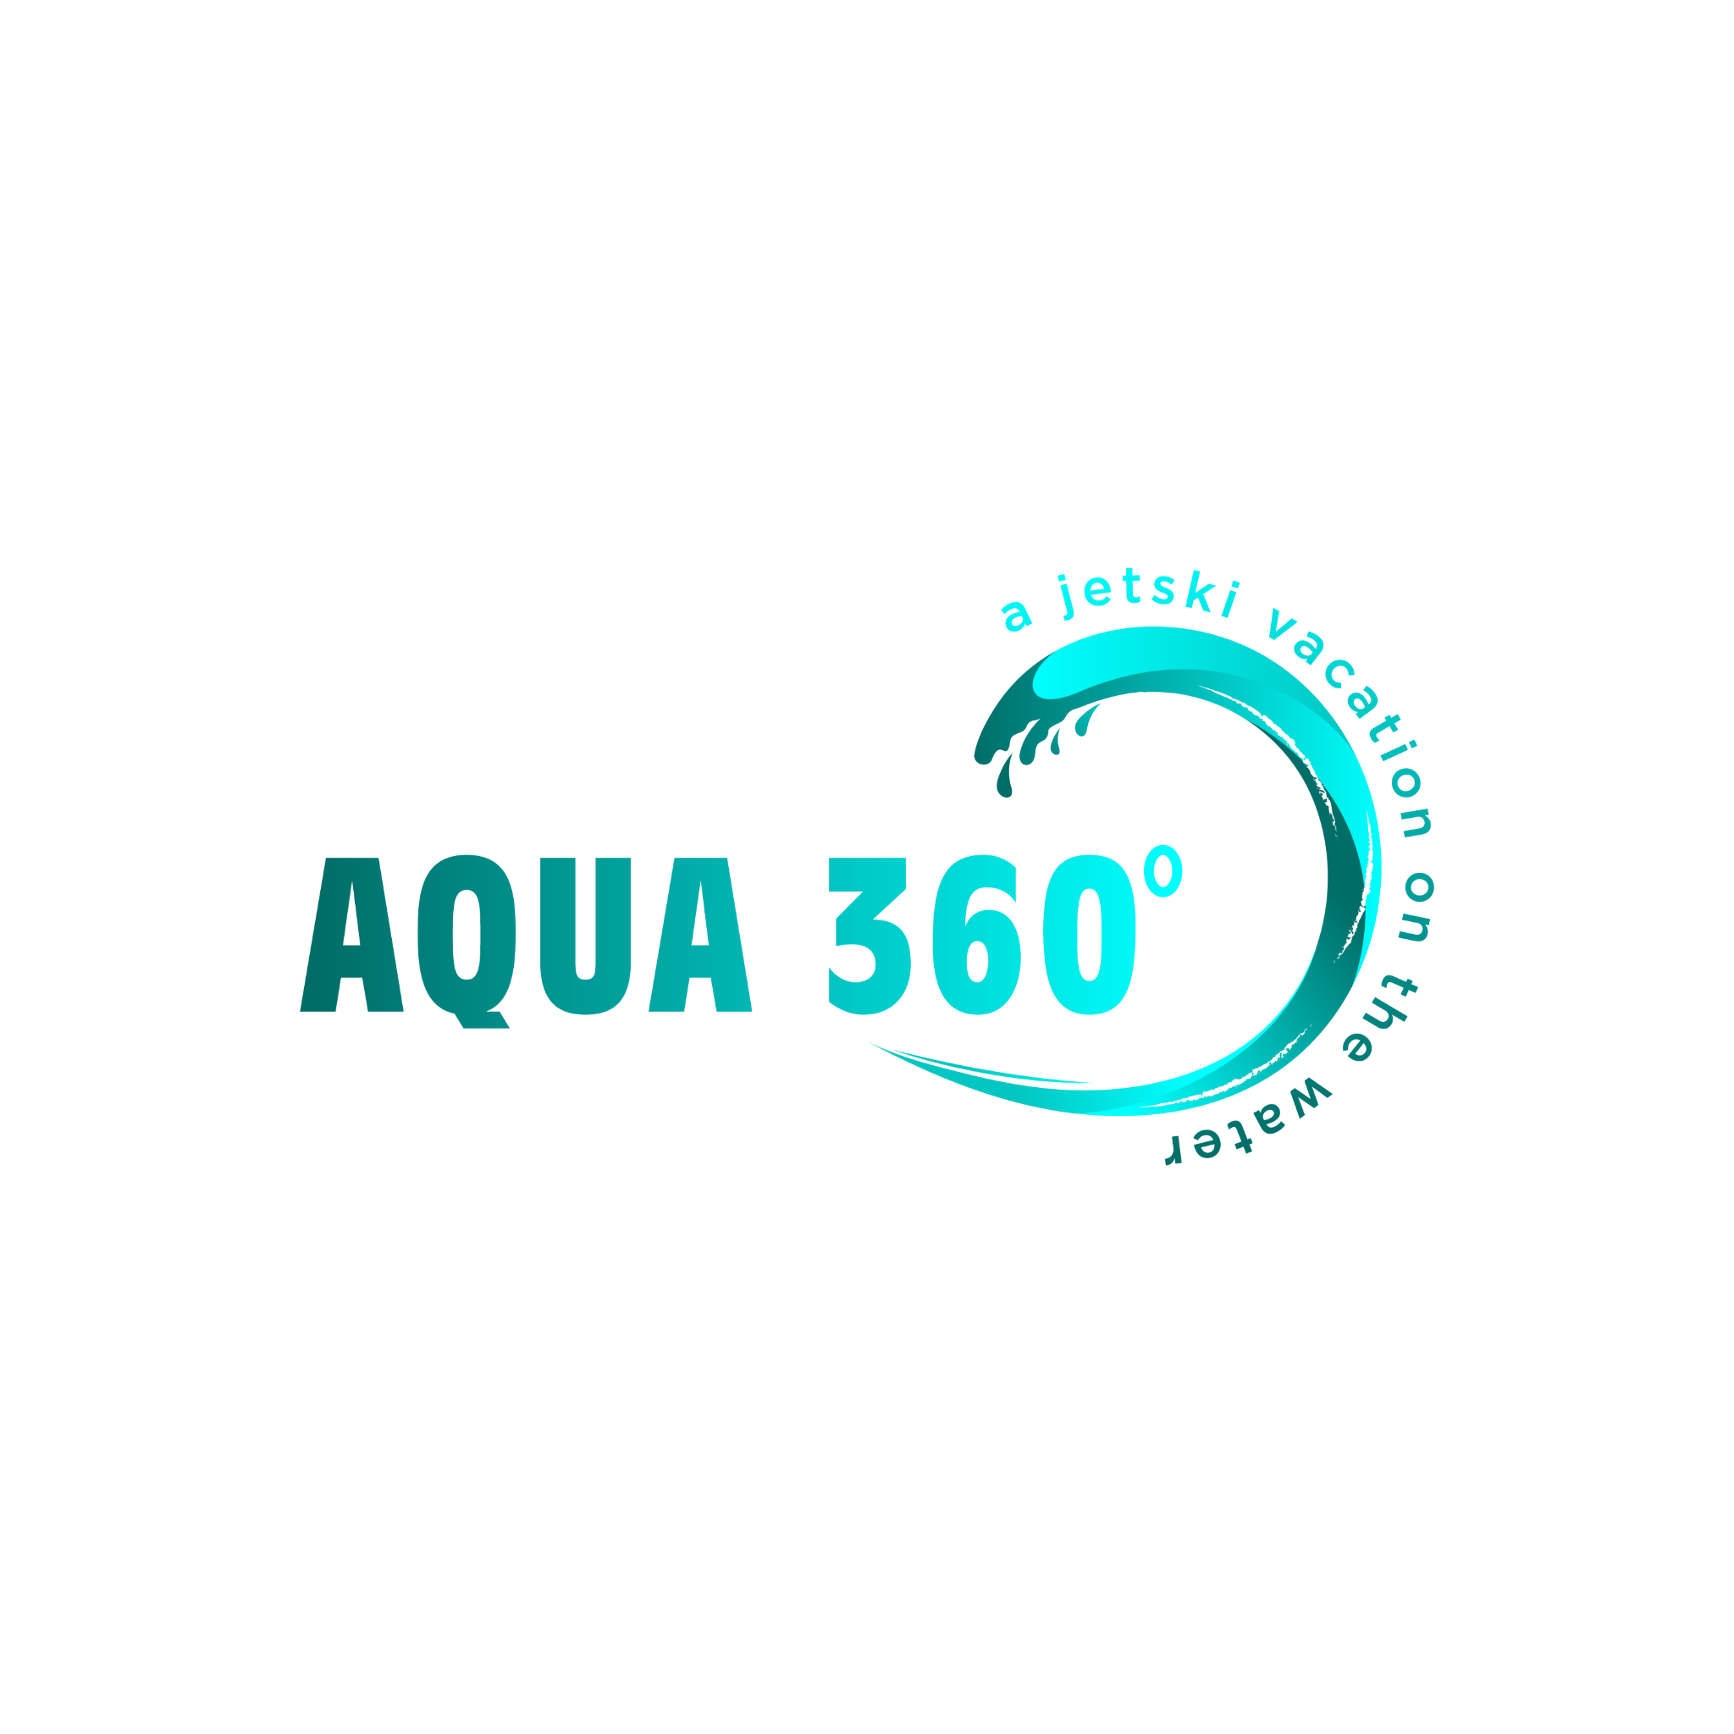**AQUA 360° WAIVER FORM**

1. **Disclaimer**

This Waiver agreement is applicable to all operators, passengers, and users of equipment provided by AQUA XTREME LTD (trading as AQUA 360°). For purposes of this waiver, AQUA XTREME LTD / AQUA 360° includes all directors, shareholders, employees and volunteers of AQUA XTREME LTD.

1. **Standard Terms and Conditions**

Aqua 360° reserves the right to cancel or postpone bookings at its sole discretion or will refund you purchase price if cancelled or postponed by us. All prices are listed in New Zealand dollars (NZD) and are inclusive of GST. Unless otherwise specified, prices are valid from 17th November 2024 to 31 May 2025 and may change without notice.

We, our directors and employees will not be liable to you in contract, tort (including negligence), breach of legislative requirements, damage to property, personal injury, disability, illness or death suffered by your or any other person as a result of the use of the equipment or in connection with any services provided or any act/omission of any person. If for any reason we do become liable to you or any other person for any reason including contract, tort (including negligence), breach of legislative requirements, damage to property, personal injury, our total liability is limited to the fees you have paid to us for the use of equipment and provisions of the services to you.

You and any other person operating the novel craft or using any equipment must sign this acknowledgement, waiver/release form before you may participate in any service.

1. **Cancellation Policy**

Aqua 360° reserves the right to cancel or amend any booking due to water/weather conditions or unforeseen circumstances at any stage. In this case clients are given an option to rebook or receive a full refund.

No-shows or cancellations made within 48 hours of booking are non-refundable and non-transferable. i.e. no refund will be given.

**COVID-19 cancellation policy:** If you are unable to make your booking due to isolation requirements, you are sick or have cold, flu/COVID-19 symptoms you will be offered the choice of rescheduling your booking or a refund (must give at least 24 hours notice). If you are sick or have cold, flu or COVID-19 symptoms, stay home and call your doctor or Healthline on 0800 358 5453 to see if you need a test.

NOTE - Refunds are granted solely at the discretion of Aqua 360° Management. *Credit card surcharges and surcharge refunds are subject to local banks etc.*

1. **Conditions of Payment**

Full rental payment required to secure booking. Refunds will be subject to no damage to the vessel/s or equipment.

We accept payments via EFTPOS, Afterpay, PayPal, cash, and PayWave.

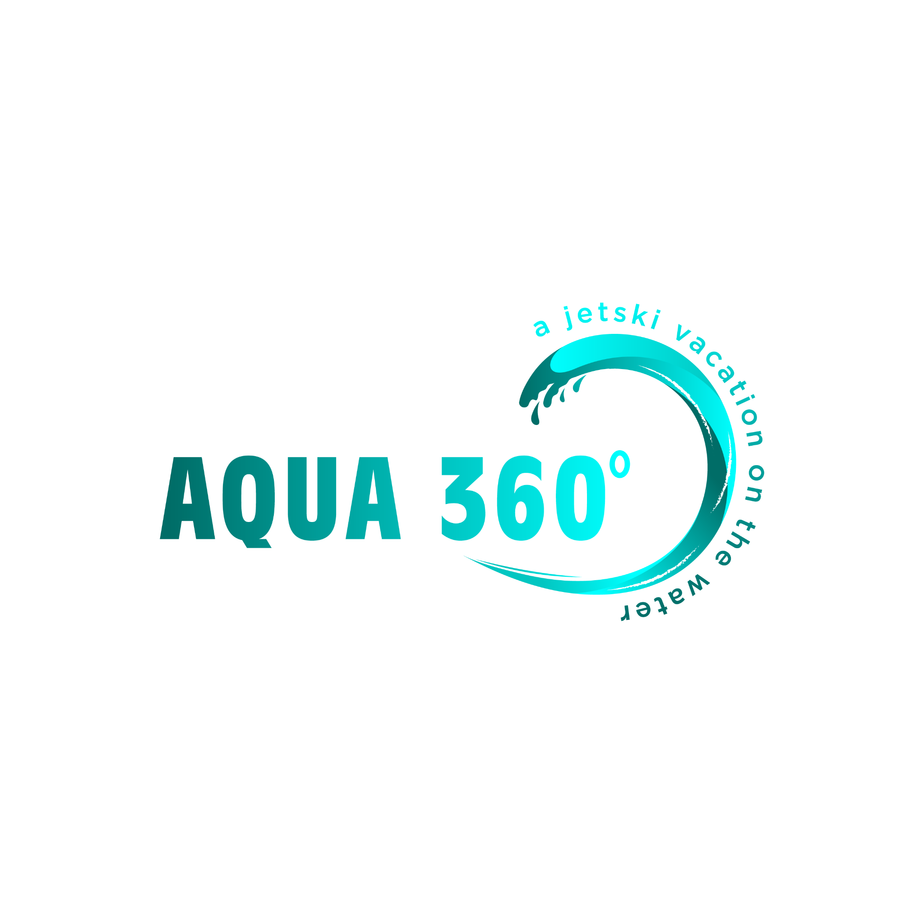



1. **Use**
2. **Hirers must be able bodied to flip the jet-ski up-right, in the event the jet-ski flips upside down.**
3. **Hirers must be able to re-board the jet-ski safely.**
4. Minimum age of **18** years to hire novel craft.
5. Minimum age of **16** years (under supervision of hirer) to operate novel craft.
6. All drivers must have a valid driver's licence (learners acceptable)
7. Maximum speed of **5 knots** within 200m of shoreline.
8. Maximum speed of 5 knots within 50m of other vessels or persons.
9. Maximum speed of 5 knots within 200 metres of the blue and white dive flag.
10. Tether cord must be worn by skipper at all times whilst operating novel craft.
11. Maximum of 2 passengers/200kgs allowed on vessel.
12. Driver and passengers must be wearing a correctly fitted life jacket at all times whilst operating the novel craft.
13. If towing a ski tube or biscuit, there must be an observer/spotter (min. Age of 10 years old)
14. The novel craft must not be used in water shallower that 1 metre or damage to the hull, engine, impellers or associated workings for the jet ski will be the sole responsibility of the hirer.
15. Novel craft must not operate between the hours of darkness (sunset to sunrise)
16. The novel craft will not be used by persons under the influence of alcohol, drugs, or judgement impairing substances during the hire period.
17. The hirer will exercise proper care and due diligence for the safety of the novel craft and will not jeopardise any insurance claims that may arise while the novel craft and equipment is in the hirer’s care.
18. The novel craft must be driven by or under direct instruction by the hirer who signed for it.
19. The hirer does not have any medical conditions that may affect his/her ability to operate the novel craft safely.
20. The novel craft must be used within the designated course set out by the operator.
21. Any time exceeding the agreed-upon hours will incur an additional charge of **$25** for every 5-minute increment.
22. If a rescue is required due to failure to follow guidelines or misuse of our watercraft, a call-out fee of **$50** will apply, along with the standard hourly rate for the duration of the rescue."
23. **Breach of law and regulations**
24. The hirer shall be responsible for any costs resulting from breaches of Maritime Law, vehicle laws or regulations including traffic and parking fines.
25. Aqua 360° reserves the right to remove the novel craft and equipment from the hirer’s possession if in breach of the terms of this contract or at the discretion of Aqua 360°.
26. **Damage and Accidents**

Should the novel craft and/or equipment be involved in an accident or sustain loss whilst in care of the hirer, Aqua 360° must be informed immediately. The following steps must be taken:

1. Obtain the name and address of the operator of any other vessels involved as well as the contact details (name and address) of their insurance company.
2. Obtain contact details of any witnesses.
3. Indemnity and insurance
4. Insurance on the novel craft will be provided by Aqua Xtreme Ltd. Excess of **$2500** will be liable to the signature of this waiver.
5. In the event of an accident, the hirer will complete any insurance forms required by Aqua Xtreme Ltd and will cooperate for any insurance purposes and for any third party claims made against Aqua 360°.
6. The hirer agrees that all bonds will be retained in the event of an insurance claim having to be submitted in order to cover excess.
7. The hirer indemnifies Aqua Xtreme Ltd from all claims of whatever nature that may result from the hire of the novel craft and/or equipment.
8. If a towing accessory rope becomes tangled or sucked into the jet ski, a **$150 f**ee will be charged to cover the cost of repairs and rope replacement.
9. Any damage to the Aqua Lounge package during the rental period will be the responsibility of the hirer and must be paid for.

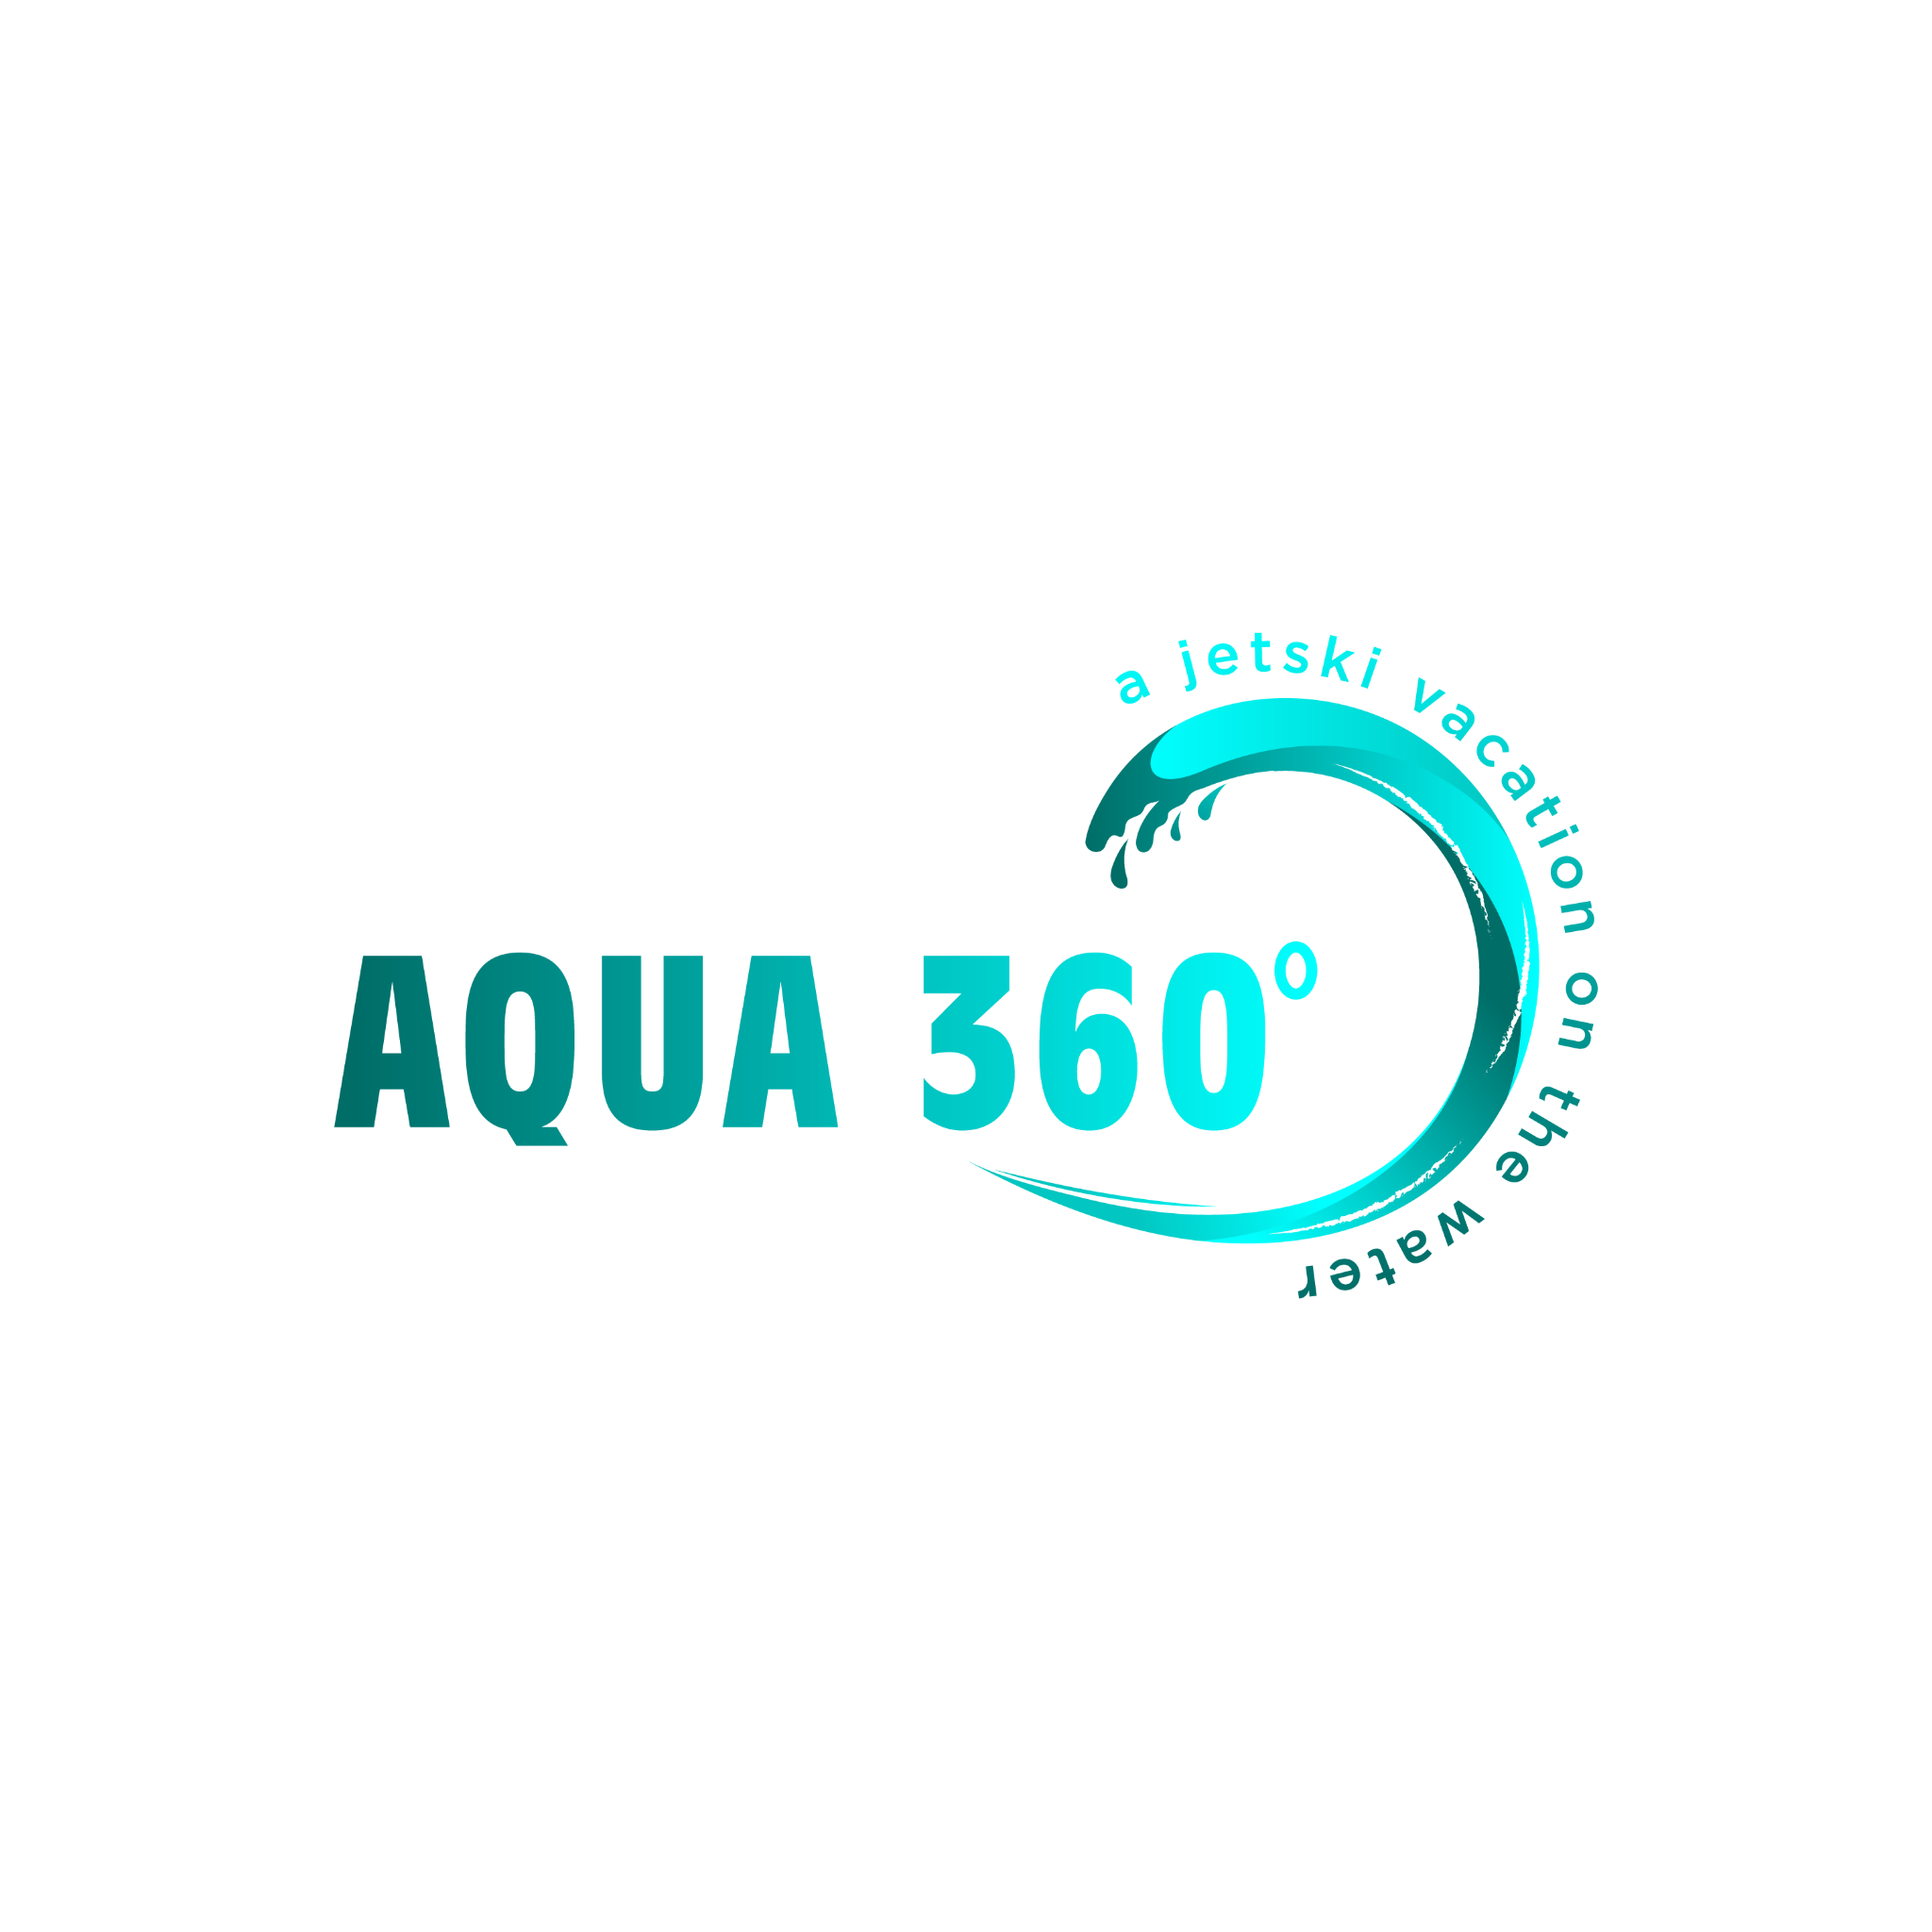**AQUA 360°**

**HIRE AGREEMENT**

The hirer is responsible to ensure he/she and those who operate any novel craft and/or equipment observe and agree to the full terms and conditions set out in this waiver prior to hiring. Failing to comply with any of the above statements will cause Aqua 360° to exercise their rights in holding partial/all bonds amount and removing any novel craft and/or equipment from their possession.

**Hirer's Contact Details:**

______________________ _________________________

First Name* Last Name*

______________________

Phone*

______________________

Date of Birth* (dd/mm/yyyy)

______________________

Email Address*

______________________

Hirer's Signature*

**Address**

__________________________________________________________________

Address Line 1* (street number, street name and city)

**Emergency Contact Details**

______________________ ______________________

First Name* Last Name*

______________________

Phone Number*

**Driver's Licence Details**

_______________________

#1 Drivers Licence/ID Number*

_____________________

Version No.*

_______________________

#2 Drivers Licence/ID Number*

_____________________

Version No.

_____________________ _____________________

#3 Drivers Licence/ID Number* Version No.

**Photo/video release disclaimer**

I/we hereby grant Aqua 360° permission to photograph and/or video the hirer (and/or party), and agree to use the content in any and all publications, including web-based publications, without payment or other consideration.*

* Yes
* No

**Hirers Declaration**

I/We confirm that the above details are correct and that I/we carry the appropriate current drivers licence and I/we are not disqualified or suspended from driving. I/we have fully read and understand the Waiver and Hire Agreement and the terms and conditions contained in it. I/we agree to accept the terms and conditions assigned to any service provided by Aqua 360°. I/we confirm that we fully understand the safety precautions and instructions of safely handling the watercraft whilst in operation. I/we agree to operate the novelcraft at my/our own risk. I/we acknowledge that we have received a full safety briefing and fully understand the operating limits, Maritime rules etc.*

* Yes
* No

_______________________ _______________________

Hirer's signature* Date*